Obligatory Exercise 4
Task 1:
iptables -A FORWARD -p tcp -s 192.168.20.24 -d 192.168.56.23 --dport 21 -j ACCEPT
iptables -A FORWARD -p tcp -d 192.168.20.24 -s 192.168.56.23 --dport 21 -j ACCEPT
iptables -A FORWARD -p tcp -s 192.168.20.24 -d 192.168.56.23 --dport 20 -j ACCEPT
iptables -A FORWARD -p tcp -d 192.168.20.24 -s 192.168.56.23 --dport 20 -j ACCEPT
iptables -A FORWARD -m state --state ESTABLISHED,RELATED -j ACCEPT
Task 2:
I am not sure, but I believe I got it: “xY688ASSu27”. This is the password used by someone to change a directory of “home/silje” which failed by the way. Now I know Silje’s password.
Task 3:
DH is fast and cheap which means that each time we want to establish a connection we can create a new one, communicate, and then delete them once we are done. Once we need to communicate again, we make a brand new one again which means that this new channel becomes independent from all the previous ones. We don’t do the same with public-private key pairs because they are slow and expensive (or so I am told).
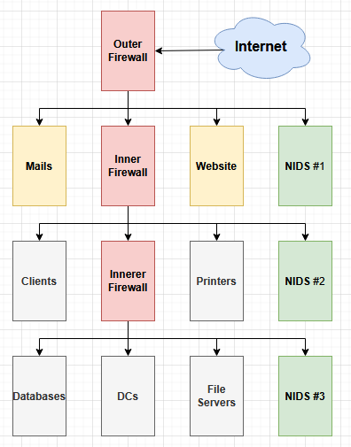
Task 4:
First and foremost a firewall and NIDS in the DMZ zone to protect against DDOS attacks. This is also the part that we want outside users to have access to. Then comes the internal part which is where employees work. There we got printers and clients which the internet should not have free access to, thus the second firewall. We also want to know if anything that is not supposed to get in is trying to get in, thus the second NIDS. Then comes what I call the innerer firewall which protects all the sensitive files, data, and DCs which control client privileges. And we also add a third IDS there, it is important to protect sensitive data. Although the second NIDS might be overkill since the third can be configured for that too.
Task 5:
alert tcp any any -> 10.0.23.23 3389 (msg "Attempted RDP connection to 10.0.23.23")
Task 6:
Basically, we use machine learning to first teach the IDS what is normal, and then once we are confident it can identify activities correctly, we launch it for real and watch it catch whatever IDS has to catch, so port scans, SQL injection attempts, DDOS attacks, etc.
Task 7:
Basically, we set up a device that is poorly protected just to see what the attacker is up to. The attacker might give up thinking there was nothing of value here, and we learn a little bit about the intentions too. We also get to know that we do have an attacker targeting us too and hopefully where from. Yes, it is a trap. There is also like a cheap version of it where we just create a fake IP address that should never be pinged, and if it is, then something’s up.
Task 8:
Outside outer firewall: The positive is that we get lots of data, the negative is that we get lots of data. Too many false positives, but also more time to react if we sense danger. Inside outer firewall: The positive is that we don’t get enough data, but also just enough data. We are not overloaded with constant pings, but we don’t have a way to detect properly and therefore have enough time to react if the actual threat is on the way. But I honestly am not sure about that, that is just what I think since firewalls are supposed to filter the junk and isolate to protect systems and integrity within.
Task 9:
These are the IPs that are not used on purpose which allows us to detect if someone is actively trying to scan and map the network, find vulnerabilities, and that in general the traffic is not legitimate.
Task 10:
VPN gives control. First of all, we can enforce policies and regulations. Some websites we don’t want to be visited and block them (flashbacks from when I was in middle school and chess.com was blocked). But, most importantly employees are going through a secure network over to the internet (redirected to go through a firewall by the VPN). Their IPs can’t be tracked exactly and therefore cannot be targeted directly.

